DETERMINING LATITUDE AND LONGITUDE
OBSERVING ONLY ONE STAR

Roland BONINSEGNA
"EAAE Summerschools" Working Group
Centre Scientifique Fleurus-Sivry (Belgium)

Abstract:
Imagine that you are lost somewhere on an isolated island. Without a GPS set, you would be unable to inform somebody about your position. However, a simple way exists to determine it with less than 1 degree error. To perform it, you will need only a few material:
- a clock with less than one minute error
- a straight stick of 2,5 m height
- a string
- two little pickets
- a plumb-line
- a pocket calculator
You will also need to know:
- the date
- the number of hour shift between your watch and the universal time
- the catalogued position of the star you will observe (right ascension, declination)
First of all, determine your local meridian using a stick and a string during a sunny day. Then during the night, time the occultation of a bright star behind the stick on the line of the local meridian and check the height of the star from your observing point. All these observation are naked eye observations.
To find your position, you will use these data:
- time of star transit
- apparent height of the star
- height of the eyes of the observer during the observation
- distance of the observer from the occulting stick
The three last data will unable us to determine the latitude using the trigonometry and the characteristic of similar triangles. The timing of the transit of the star convert into universal time, will correspond to the local sidereal time which can be compared with the simultaneous Greenwich sidereal time to determine the longitude.
We could however take in account two eventual corrections:
- precession, which can be neglected until 2010
- atmospheric refraction, which can be neglected for stars higher than 10 degrees above horizon.
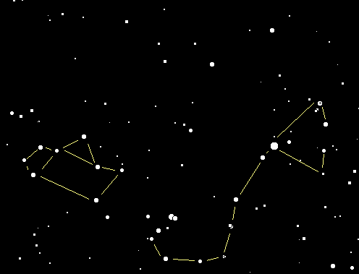

Introduction
One of the major problem for sea navigation was the longitude determination. One major step was achieve during the XVIII th century owing to John Harrison. At least, it was possible to use a reliable clock which allowed to compare the stars positions observed by the sailors to the ephemeris . The difference between the observations and the predictions allowed to precise the longitude. Today, of course, the technical progress have rejected that method. However, if someday you were lost on an isolated island without a GPS (Global Positioning System), that old system would certainly suit you. We shall see how to use it in order to determine the geographical position to better than 1 degree.

Material required.
a)
- a watch with less than one minute error
- a straight stick of about 2,5 m height
- a string
- two little pickets
- a plumb-line
- a pocket calculator
b) It must be necessary to know:
- the date
- the number of hour shift between your watch and the universal time
- the catalogued position of the star you will observe (right ascension, declination)

Drawing the local meridian during daytime.
a) Set up the stick J on a flat surface. Verify the verticality with a plumb-line and adjust it.
b) Around three to two hours before the sun transit at the local meridian, draw from the stick and using the string, an arc with a radius R, equal to the length of the stick shadow at that very moment. Set up a little picket A at the end of the shadow. In order to better determine the place of A, use a white sheet of paper and align one edge parallel to the shadow axis, the better contrast will allow to point the right spot.
c) Wait for two or three hours after the sun transit and look out for the moment when the stick shadow will touch again the circle. Set up a little picket B at the end of the shadow.
d) Draw the bisection of the angle constructed from the two radiuses JA, JB using the string. The bisection line is the local meridian. Extend that meridian toward north for 4 to 5 m (see figure 1).
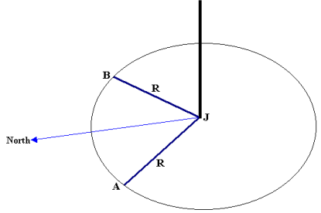
Figure 1: Local meridian outline

Observation of the transit of a star at the local meridian.
a) Install yourself on a low chair, to be well up on the local meridian drawn on the ground, ready to observe the target star which stand at the left of the higher part of the stick For the observer, the earth rotation will induce the nearness of the star from the stick.
b) Some moments before the star transit behind the stick. The best way to achieve a good observation is to sight the star and the stick through a sighting tube (around 30 cm long and 1 cm in diameter) bound on a stable support (a tripod) and aligned with the local meridian. The observer does not move anymore and, with one eye, wait for the star occultation behind the stick.
c) At the moment of the star instantaneous disappearance, the observer (or an assistant) record the time to the nearest second (t₁). The same, some seconds later, when the star reappears on the other side of the stick (t₂). See figure 2.
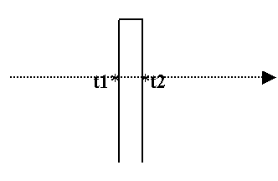
Figure 2: Timing the disappearance (t₁) and the reappearance (t₂) of the star behind the stick.
These instants, along with the date and the star position, allow a longitude determination.
d) Immediately thereafter, the apparent height of the star must be measured: an assistant move a little lamp or diode all along the stick, up to reach the altitude of the target. That height must be measured (a). See figure 3.
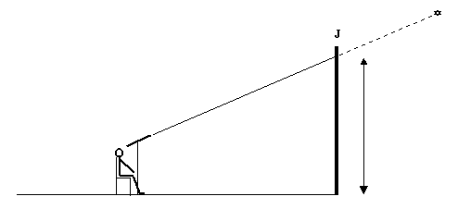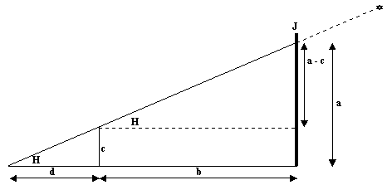
Figure 3: The observer is seat down at the same place as c and observes the occultation of the target star by the stick J. For him, the star altitude seems equal to a, the distance between the stick and himself is represented by b, the height from his eyes from to the ground equals c. As the triangles are similar, we can deduce the value of H tangent. This angle, in relation with the star position allows determining the geographical latitude.
e) Finally, the distance between the observer's eye and the stick (b), the height of the observer's eye above the ground (c) must be measured. See figure 3.
We advice you to choose a star which will be not too high above the horizon, in order not to use a too high stick. Also the star must not be too low, in order to avoid the atmospheric refraction correction. The best choice would be target stars which height during transit should be between 30 and 15 degrees. A list of proposed stars is presented in table 1.

Reducing the observations.

a) To find your position, you will use these data :
- Universal time of star transit at the local meridian 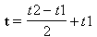
t expressed in hours and decimals must be transformed in DEGREES (t/24 * 360)
- apparent height of the star at transit (a)
- the distance between the observer and the stick (b)
- the height of the observer's eye above the ground (c)
a, b, c are expressed in the same unity (m, cm, mm).
- the date
- the star position: right ascension (α) and declination (δ)
α expressed in h, min, s of time must be converted in HOURS and decimals then in DEGREES (t/24 * 360)
δ expressed in degrees, minutes of degree, seconds of degree must be converted in DEGREES and decimals

b) Calculation of the latitude:ϕ'
From Thales of Milet ( 625 - 547 BC) - (see figure 3).
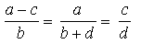
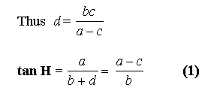
The value of H angle, height of the star above the 'horizon, allow to calculate the latitude (ϕ') of the observer.

ϕ = 90° - H + δ (2)
As the Earth is not a perfect sphere:

tan ϕ' = 0.9933 tan ϕ (3)

c) Calculation of the longitude: λ
1) Count the number of days between the observing date and January 1st 2000, included. For example, there is 35 days between January 1st 2000 and February 4th 2000; 379 days between January 1st 2000 and January 13th 2001.

NJ = Number of days - 1.5
2) Calculation of T : number of centuries between the observing date and year 2000

T = NJ / 36525 (4)
Of course, the value of T will be inferior to 1 till 2099.
3) Calculation of sidereal time at Greenwich at 0 h U.T.

θ₀ = 100.4606 + (36000.7701 T) (5)
That number is expressed in degrees, it may be necessary to reduce it between the interval 0 - 360°
4) Calculation of the longitude

λ = θ₀ - α + (1.0027 t) (6)

Corrections.
We advice to use one correction:
precession correction (which can be neglected till 2010 for the accuracy needed)

Δα = 3.075 + 1.336 sin α tan δ (7) expressed in seconds of time
Δδ = 20.04 cos α (8) expressed in seconds of degree
n = number of years since 2000

These two values, multiplied by the number of years since 2000, must be added to :
- α 2000 expressed in h, min, s
- δ 2000 expressed in degrees, minutes of degree, seconds of degree

α = α 2000 + n Δα (9)
δ = δ 2000 + n Δδ (10)
See table 1 to avoid this correction for the next years.

Example.
A person observes the transit of α Sco (Antares) at her local meridian. Here are the results of her observations:
- the instant of star transit t = 23h 15min 06s U. T.
- apparent height of the star at transit (a): 2.20 m
- the distance between the observer and the stick (b): 3.00 m
- the height of the observer's eye above the ground (c): 0.80 m
- the date: May 15 2000
- star position: right ascension (α) and declination (δ) (see table 1):
α: 16h 29min 24.4s
δ: -26° 25' 55"

a) Unity conversion:
- time of transit t = 23h 15min 06s T.U. = 23.25167 h = 348.7751 °
- star position: right ascension (α) and declination (δ) (see table 1):
α: 16h 29min 24.4s α: 16.49011 h α: 247.3517 °
δ: -26° 25' 55" δ: -26.4319 °

b) Calculation for the latitude: ϕ'
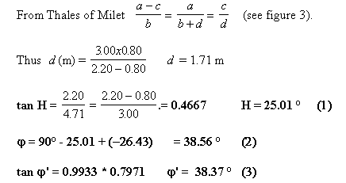
We mean north latitude.

c) Calculation for the longitude: λ

NJ = 136 - 1.5

T = 134,5 / 36525 = 0.003682409 (4)

θ₀ = 100.4606 + (36000.7701 * 0.003682409) = 233.0302 ° (5)

λ = 233.0302 - 247.3517 + (1.0027 * 348.7751) = 335.40 ° (6)
It refers to the West longitude, which can be also expressed:
335.40 ° - 360 ° = - 24.60 ° or 24.60 east longitude.
With some care, using this method, it is possible to determine the geographical position with less than 0.1° error.
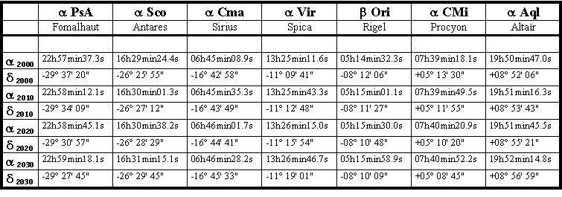
Table 1: Target stars suited for latitudes between 30 and 70 degrees.

References:
  - Meeus Jean, 1991, Astronomical Algorithms, Willmann-Bell, Inc.
  - Sobel Dava, 1997, Longitudine, Rizzoli ed.

